Manual for Automation Testing

**Index**

# Software Required

# Software Installation

# Input to be configured

# Run configuration

# Report

# Software Required

Following software are required to create the automation environment

1. Java JDK (jdk-12.0.1)
2. Android SDK
3. Node JS (6.9.0)
4. Maven (3.6.0)
5. Appium (1.12.1) – Terminal Based
6. Mobile Device – Samsung A8 with OS version 9
7. PgAdmin (4.7v)

# Software Installation

1. Java JDK:
   1. Download the java JDK from <https://www.oracle.com/technetwork/java/javase/downloads/jdk8-downloads-2133151.html>
   2. Install the Java jdk and set the java bin path and variable (Add JAVA_HOME = C://xxx/jdkfolder and path C://xxxx/jdk/bin)
2. Android Studio:
   1. Download Android Studio from <https://developer.android.com/studio>
   2. During the installation allow to download and install the SDK tools
   3. After installation, set the SDK tools path in environment variables
      1. ANDROID_HOME:

C:\Users\mugazp\AppData\Local\Android\Sdk

* + 1. Path:

XXXX; C:\Users\mugazp\AppData\Local\Android\Sdk\tools; C:\Users\mugazp\AppData\Local\Android\Sdk\platform-tools

* 1. After the installation go to command terminal and type: “adb devices” and verify the adb server gets started

1. Node.js:
   1. Download the node js from <https://nodejs.org/en/download/>
   2. Install the node js
   3. After Installation go to command prompt and type “npm -version”
   4. Verify the installation by version shown
2. Maven:
   1. Download [apache-maven-3.6.1-bin.zip](https://www-eu.apache.org/dist/maven/maven-3/3.6.1/binaries/apache-maven-3.6.1-bin.zip) from <https://maven.apache.org/download.cgi>
   2. Extract the maven folder and copy the path until bin folder (E:\Eclipse\maven-3.6.0\bin)
   3. Set the environment variable path as (XX; E:\Eclipse\maven-3.6.0\bin;)
   4. Open command prompt and type “mvn –version”
   5. Verify the installed verison
3. Appium Terminal Based:
   1. Open the cmd terminal and type “npm install –g appium”
   2. Wait until the installation gets completes
   3. Type “appium -v” and verify the installed appium version
4. PgAdmin:
   1. Download and install the pgadmin from <https://ftp.postgresql.org/pub/pgadmin/pgadmin4/v4.7/windows/pgadmin4-4.7-x86.exe>
   2. Launch the PgAdmin app and browser will open the local host SQL
   3. Configure the user name and password as “postgres” and “maveric”.
   4. Create a DB (Name as “DU”) under PostgreSQL

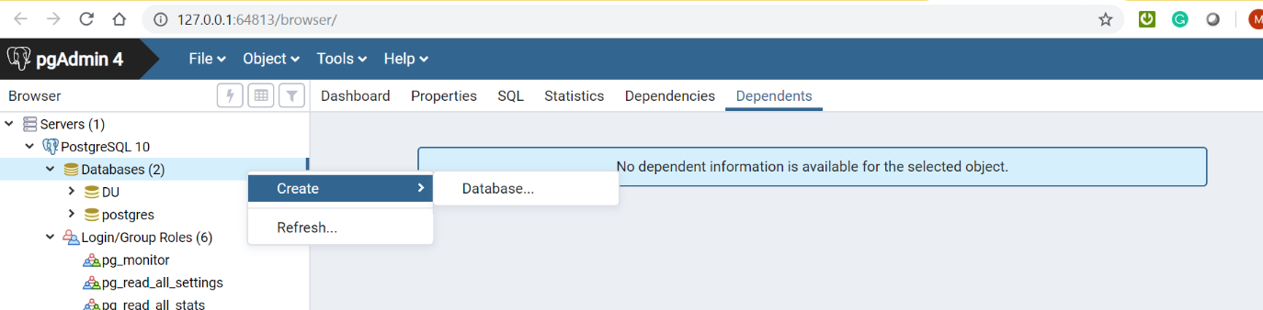

* 1. Create a table for the DB “DU” in the name “EDR_CIS_DataSamp”
  2. Tap on the flash icon and open the Query Editor Screen

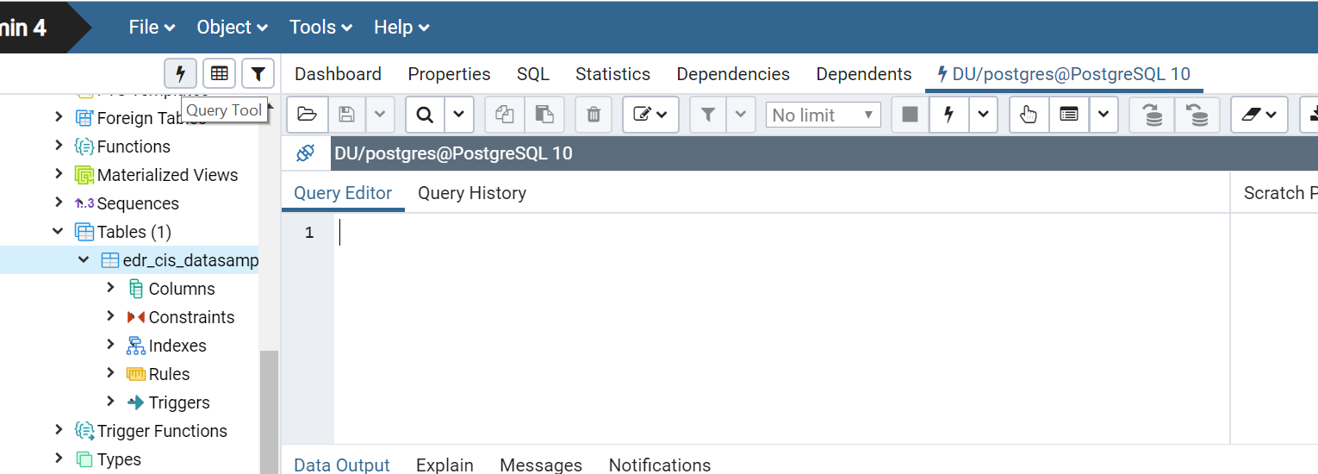

* 1. Use the create table query mentioned in the text file (DU_Query_EDR)

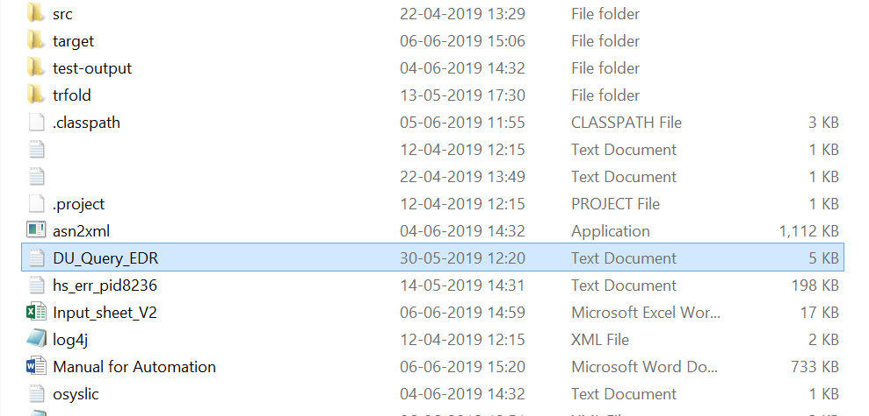

**Query**:

CREATE TABLE EDR_CIS_DataSamp (Transaction_Time Varchar(50),Client_Transaction_Id Varchar(50),Transaction_Id Varchar(50),IP_Address Varchar(50),

Event_Type Varchar(50),A_Party_Msisdn Varchar(50),B_Party_Msisdn Varchar(50),input Varchar(50),Result_Code Varchar(50),Result_Description Varchar(50),

Service_Class Varchar(50),Requested_Product_ID Varchar(50),Product_Name Varchar(50),Product_Type Varchar(50),Product_Cost Varchar(50),Applied_product_cost Varchar(50),

Product_Validity Varchar(50),Access_Channel Varchar(50),Access_Code Varchar(50),Charge_Indicator Varchar(50),Vat_Fee Varchar(50),Language_Id Varchar(50),

Iname Varchar(50),Circle_Code Varchar(50),Pay_Source Varchar(50),Send_sms Varchar(50),Skip_charging Varchar(50),Bill_Cycle_ID Varchar(50),

User_ID Varchar(50),Origin_Host Varchar(50),Faf_Indicator Varchar(50),Faf_MSISDN Varchar(50),Offer_ID Varchar(50),New_Imei Varchar(50),Old_Imei Varchar(50),

Dealer_ID Varchar(50),Transfer_Remark Varchar(50),DrCr Varchar(50),Subscription_Date Varchar(50),Expiry_Date Varchar(50),Last_Renewal_Date Varchar(50),

Grace_Expiry_Date Varchar(50),Status Varchar(50),Subscription_Mode Varchar(50),Network_Status Varchar(50),Last_Status Varchar(50),Status_Change_time Varchar(50),

Command_Count Varchar(50),Charging_Session_Id Varchar(50),Notification_Message Varchar(3000),Commission_Fee Varchar(50),Transfer_Fee Varchar(50),GL_Code Varchar(50),

State Varchar(50),Subscriber_Type Varchar(50),OpParam1 Varchar(50),OpParam2 Varchar(50),OpParam3 Varchar(50),OpParam4 Varchar(50),OpParam5 Varchar(50),OpParam6 Varchar(50),

OpParam7 Varchar(50),OpParam8 Varchar(50),OpParam9 Varchar(50),OpParam10 Varchar(50),OpParam11 Varchar(50),OpParam12 Varchar(50),TDF_Event_Class Varchar(50),

TDF_Event_Name Varchar(50),TDF_Voucher_Type Varchar(50),TDF_Periodic_Charge Varchar(50),TDF_Usage Varchar(50),External_Data1 Varchar(50),External_Data2 Varchar(50),

External_Data3 Varchar(50),External_Data4 Varchar(50),Callback Varchar(50),ParentProductSPInfo Varchar(50))

# Input to be configured

1. Download the project folder and unzip to any folder location
2. Open the project folder and open the input sheet/xmsl

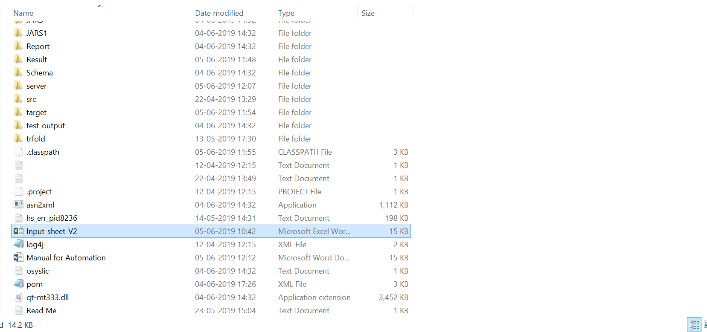

1. Configure the input data:
   1. Execution Control (Mandatory field):
      1. Choose **Yes** for the test scenarios to be executed
      2. Choose **No** for the test scenario to skip from execution

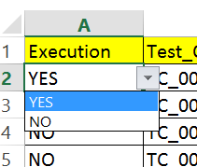

* 1. Test Case ID(Mandatory field):
     1. Enter the test case id (TC_001_01)

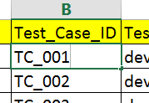

* 1. Test Device:
     1. Need to set the device properties as per the device model and version we are using. Below are the steps to configure the device properties
        1. Goto the folder path “src\test\resources\config”
        2. Open the device.properties file (Ex: device1.properties)
        3. Go to cmd terminal and type “adb devices”

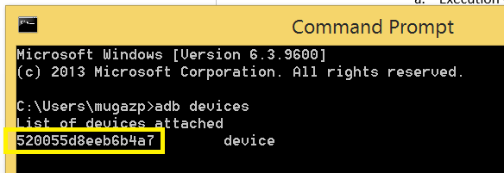

* + - 1. Copy the device name and version of the device to properties file

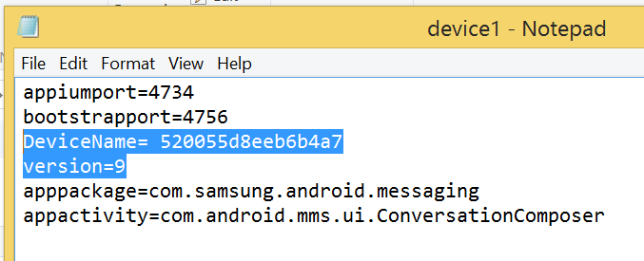

2. Enter the Test_Device (**device1**.properties) in the input sheet as device1

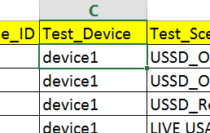

* 1. Test_Scenario:
     1. Choose the test scenario to be executed

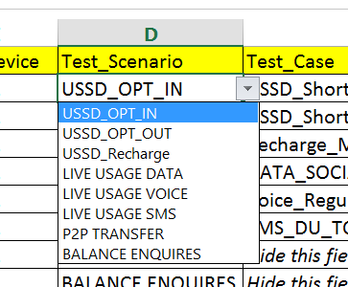

* 1. Test Case:
     1. As per the chosen Test Scenario, the test cases are prepopulated

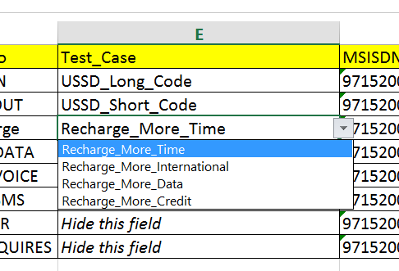

2. Choose the Test Case to be executed

* 1. MSISDN: Enter the MSISDN number which to be used for execution

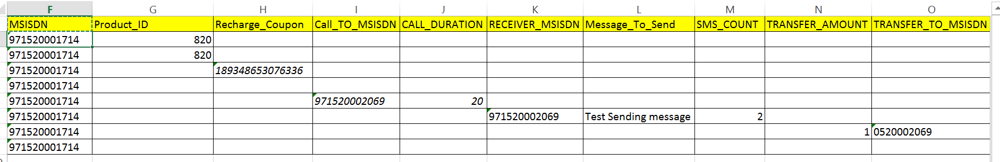

* 1. Product_ID: Choose the product ID to execute
  2. Recharge_Coupon: Enter the recharge coupon when the test scenario and test case chosen for recharge
  3. Call_TO_MSISDN: Enter the MSISDN of receiver when the test scenario is chosen as Voice call
  4. Call_Duration: Enter the time duration in Seconds when the test scenario is chosen as Voice call
  5. Receiver MSISDN: Enter the receiver MSISDN when the test scenario is chosen as SMS
  6. Message To Send: Enter the text for the message to need be send when the test scenario is chosen as SMS
  7. SMS_Count: Enter the number of times the SMS need to be send to the receiver when the Test Scenario is chosen as SMS
  8. Transfer Amount: Enter the amount to be transferred in AED, when the Test Scenario is chosen as P2P Transfer
  9. Transfer to MSISDN: Enter the MSISDN of the receiver, when the Test Scenario is chosen as P2P Transfer

Add the test scenarios as mentioned above and save the input sheet for the execution

# Run configuration

1. Navigate to project folder as below

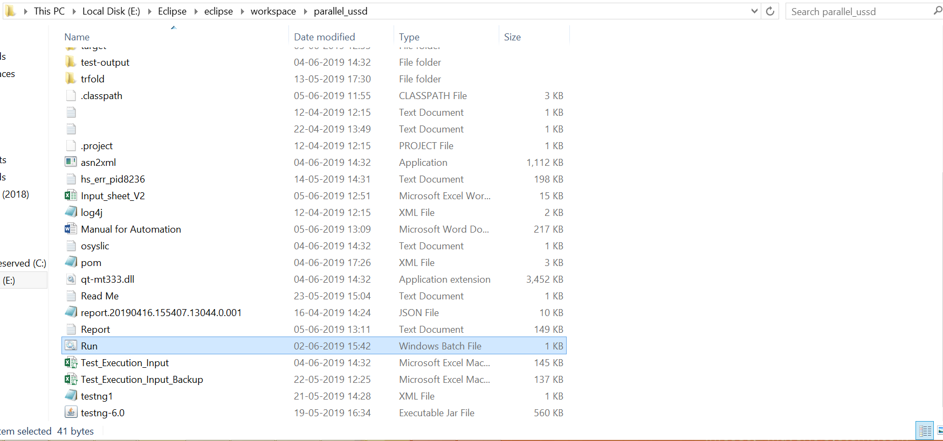

1. Double click on the "Run.bat” file

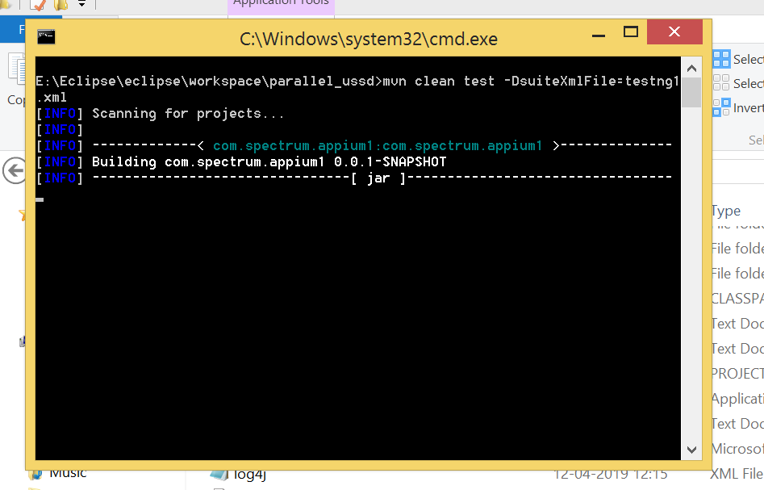

# Report

1. After the execution completes, the reports are generated in the following paths:

ProjectName\Result\DD-MMM-YYYY\ DD-MMM-YYYY _HH-MM-SS

EX: ProjectName\Result\05-Jun-2019\05-Jun-2019_13-29-00

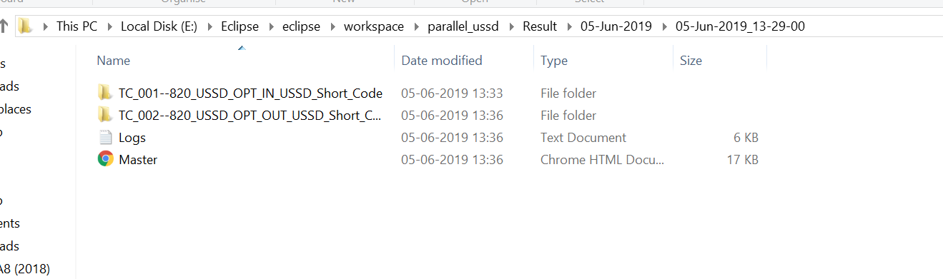

1. Each Test Case Folder contains related CDR folder and device execution screenshots

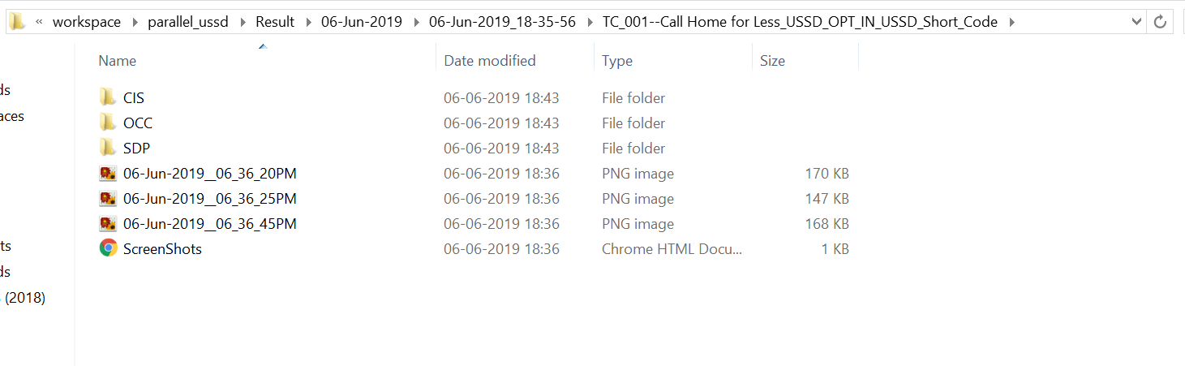

1. Master.HTML Contains
   1. Overall Report for the execution (Test Case Id, Test Scenario, Test Case, Product Name, etc)
   2. Related Device execution screenshots
   3. CDR and EDR xml file link
   4. Selected CDR parameter values

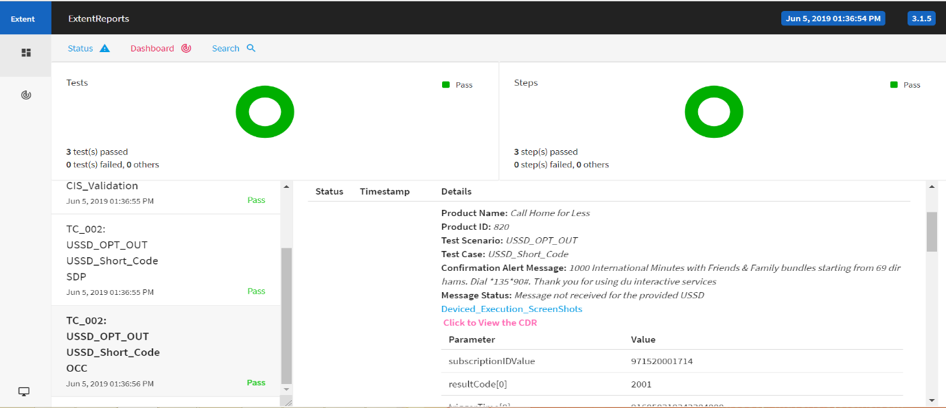

1. Backup of Raw CDR Files
   1. Path: ProjectName\BackupCDR\FileType

